Chapter I
Introduction
To Study the Relationship Between Household Spending and Investment Practices among Working Professionals
In today’s rapidly changing world, managing personal finances has become more important than ever before. With the growth of the economy, increasing job opportunities, and rising income levels, individuals now have more financial choices and responsibilities. However, along with increased income, there has also been a significant rise in expenses due to changing lifestyles, inflation, and higher expectations. As a result, individuals often find it challenging to balance their income between household spending and investment for the future.
In earlier times, people has limited needs and simpler lifestyles. Most of their income was spent on basic necessities such as food, shelter, and clothing, and the remaining amount was usually saved for future use. Investment options were also limited, and people mainly depended on traditional saving methods like bank deposits or gold. But over time, with the development of financial markets, technology, and globalization, both spending patterns and investment opportunities have changed significantly. Today, individuals are exposed to a wide range of consumption choices as well as multiple investment options, which has made financial decision-making more complex.
Household spending plays a very important role in shaping an individual’s financial condition. It includes all types of expenses such as food, rent or housing, electricity, transportation, education, healthcare, and other daily requirements. In addition to these, people also spend on lifestyle-related activities such as entertainment, travel, shopping dinning out and gadgets. With increasing social influence and the desire to maintain a certain standard of living, individuals sometimes spend more than necessary. Easy access to credit cards, loans and online shopping platforms has further increased spending behavior, making it difficult for individuals to control their expenses.
At the same time, investment has become a key factor in ensuring financial security and long-term stability. Investment is not just about saving money but about making money grow over time. It helps individuals achieve important life goals such as higher education, buying a house, starting a business, and planning for retirement. In today’s uncertain environment, where unexpected situations like medical emergencies or job loss can arise, having proper investments becomes very important. Various investment options such as mutual funds, stocks, fixed deposits, insurance, and gold are available, but choosing the right option requires knowledge, planning, and discipline.
Despite the importance of investment, many individuals fail to invest regularly. One of the major reasons behind this issue is the increasing level of household expenditure. As expenses rise, the amount of disposable income available for saving and investment decreases. This creates an imbalance between present consumption and future financial planning. In many cases, individuals prioritize immediate needs and desires over long-terms benefits, which affects their financial stability in the future.
This problem has become more serious in recent years due to several reasons. Changing lifestyles patterns, increased cost of living, peer pressure, and social media influence have encouraged people to spend more. At the same time, lack of financial awareness and poor budgeting habits have made it difficult for individuals to manage their money effectively. Even among working professionals, who earn a regular income, there is often reduce the time and attention given to financial management, leading to irregular saving and investment habits.
Another important aspect of this problem is the difference in financial behavior among individuals. Factors such as income level, education, occupation, gender, and financial knowledge play a significant role in determining how people spend and invest their money. For example, individuals with higher financial awareness are more likely to control their spending and invest wisely, while other may struggle due to lack of knowledge or discipline. Similarly, students who have started investing early may develop better financial habits compared to those who do not have exposure to financial planning.
The present study is conducted to understand this real-life issue in a structured and practical manner. The main reason for choosing this topic is to analyze the relationship between household spending and investment practices among working professionals and individual who manage their own income. The study aims to find out whether higher spending reduces the ability to invest and how financial behavior affects decision-making. It also focuses on understanding the role of budgeting, financial awareness, and income management in improving investment practices. This study is particularly important in today’s context, as more and more young individuals are entering the workforce and starting to earn their own income. Many of them face difficulties in managing their finances due to lack of experiences and knowledge. By studying this topic, awareness can be created about the importance of controlling expenses, saving regularly, and investing wisely. It helps individuals understand that financial planning is not only necessary for the future but also for maintaining a stable and stress-free present life.
Furthermore, this study has practical significance as it is based on real data collected from respondents. It reflects the actual financial behavior, habits, and challenges faced by individuals. The findings of the study can help people identify their own spending patterns and improve their investment decisions. It also provides useful insights for students, working professionals, and researchers who are interested in understanding personal finance and financial decision-making.
In conclusion, the relationship between household spending and investment practices is a crucial aspect of personal financial management. Proper balance between the two is necessary to ensure financial stability and long-term security. This study highlights the importance of managing income wisely and encourages individuals to adopts better financial habits. By understanding and improving this balance, individuals can achieve their financial goals and lead a more secure and well-planned life.
1. Statement of the Problem:
In today’s changing economic environment, working professionals earn income bur often face difficulty in managing it effectively. A large portion of their income is spent on household expenses as food, rent, transportation, education, and other daily needs. Due to increasing living costs and lifestyle changes, these expenses are rising continuously, which makes it challenging for individuals to save and invest regularly.
At the same time, investment is very important for achieving future financial goals and ensuring long-ter financial security. However, many individuals are unable to invest adequately because their spending patterns are not well planned or controlled. In some cases, lack of financial awareness, improper budgeting, and personal habits also affects their ability to make effective investment decisions.
The main problem is that there is often an imbalance between household spending and investment practices. Some individuals tent to spend more and invest less, while others may not have a clear understanding of how to manage their incomes efficiently. This creates a gap between current financial behavior and future financial needs.
Therefore, this study aims to examine and understand the relationship between household spending and investment practices among working professionals and individuals who manage their own income. It seeks to identify how spending habits influence investment decisions investment decisions and to find ways to improve financial management for better stability and growth.
2. Objectives of the study:
In today’s financial environment, it is important to understand hos individuals manage their income between household spending and investment practices. The ways people spend and invest their money directly affects their financial stability and future security. Therefore, this study aims to analyze the financial behavior of working professionals and individuals managing their own income.
- To study the household spending patterns of working professionals.
- To examines the investment practices followed by the respondents.
- To analyze the relationship between household spending and investment behavior.
- To identify how different types of expenses affect the ability to invest.
- To understand the role of budgeting and financial planning in improving investment habits.
The above objectives helps in gaining a clear understanding of how individuals balance their income between spending and investing. The study also aims to provide useful insights that can help individuals improves their financials planning and make better investment decisions for a secure future.
3.Theoretical framework:
This study is based on the concept of personal financial management, which focuses on how individuals manage their income between spending and investment. Every working individuals earns income and has to decide how much to spend on household needs and how much to save or invest for future purposes. This decision-making plays an important role in maintaining financial stability and achieving long-term goals.
Household spending includes all regular expenses such as food, rent, transportation, education, healthcare, and other lifestyles needs. These are necessary for daily living, but if spending is high or not properly controlled, it reduces the amount of money available for saving and investment. On the other hand, investment practices involve allocating a portion of income into different financial options like saving accounts, mutual funds, stocks, gold, or other assets with the aim of earning returns and securing the future.
The basic idea behind this study is that income is limited, and individuals must divide it carefully. If a large portion of income is used for expenses, the remaining amount for investment becomes smaller. However, individuals who plan their budget, control unnecessary expenses, and have better financial awareness are able to invest more effectively.
This study assumes that there is relationship between household spending and investment practices. It tries to understand how spending behavior influences investment practices. This study is also supported by financial concepts like income allocation and financial planning, which suggest that proper management of income helps in balancing present needs and future financial security.
4 Significance of the study:
This study is important because if helps in understanding how individuals manage their income in real life. In today’s time, people earn money but often find it difficult to balance their household expenses and investments. This study highlights how spending habits affect the ability of working professionals and individuals to invest for their future.
The research is useful in showing the importance of financial planning and budgeting. It helps in understanding that uncontrolled or high household spending can reduce savings and investment capacity, while proper planning can improve financial stability. This can encourage individuals to develop better money management habits.
This study is also significant for students, working professionals, and young earners as it gives awareness about how financial decisions impact long-terms goals. It helps individuals realizes the importance of saving and investing early in life.
From an academic point of view, this study contributes to understand the relationship between household spending and investment practices. It can also be useful for future researchers who want to study personal finance behavior and financial decision-making patterns.
Overall, the significance of this study lies in promoting better financial awareness and helping individuals achieve a balanced and secure financial life.

Chapter II
REVIEW OF LITERATURE
The literature review was conducted to gain a better understanding of the topic and to study the work already done by other researchers in the field of household spending and investment practices. It helps in identifying different ideas, opinions, and findings related to financial behavior and decision-making.
By studying previous research, it becomes easier to understand how household expenses influence investment habits and what factors affect financial planning. It also helps I identifying common patterns, such as how higher spending can reduce investment capacity and how proper budgeting can improve financial stability.
The literature review also provides a strong base for the present study by supporting it with existing knowledge. It helps in comparing past findings with the current research and ensures that the study is relevant and meaningful.
Overall, reviewing the literature helps in developing a clear understanding of the topic and guides the research in the right direction.
- Literature review:
1. Balancing communities work and family in dual earner households:
(Bielby, 1989): These papers talk about how married men and women handle their work and home life. It explains how people do their job and take care of the family the study uses information from a survey done in 1977. The main finding shows that when people take part in work and family life, the more connected to both. Both men and women care about their job and family role. Earlier women mostly stayed at home. Slowly, more women started working. Because of this family life began to change. Now women do both job work and home work. This make life more busy and tiring. People started thinking more about how to manage work and family time. The paper shows how both try to balance work and home duties. Overall, the study helps us understand how families manage work and home together today.
2 What do women invest differently than men ? Financial counseling and planning:
(Bernasek, 1 Feb 1997): The recent study shows that women invest their pension money more safely and conservatively than men. These differences are important because they can affect women’s financial security after retirement. This paper reviews earlier research on gender differences in investing and risk taking. The authors explanations from the fields like economics, sociology, education and gender studies. The studies show that women usually have lower lifetime earning than men. Women also experience the slower growth, lower wealth and lower pension. Research shows that women and men differ how they take financial risks. The finding suggest that discrimination and differences in personal play a major role. The study helps to explain why women tend to choose safer investment options especially for pension.
3. The relationship between job and life satisfaction: Evidence from a remote mining community: (Roderick D. Inverson, March 1999):This study focuses on 286 male employees working in an open-cut coal mine in a remote coal-mining town in central Queensland, Australia. The researchers used LISREL to study how job satisfaction is one of the most important factors affecting life satisfaction. Job satisfaction acts as a link between work conditions and overall happiness in life. Personal and social factors such as family isolation, kinship support, positive affectively, community participation, and negative affectivity also matter. The study shows that job satisfaction has a stronger effect on life satisfaction than other things. This effect the household spending such as spending on education, health care, and daily needs. This study affects the investment and saving decisions, as satisfied workers are more confident about planning for the future.
4.Investments and investment process in professionals service groups. International journal of Production Economics: (Segelod, 10 september 2000): This article studies professional service groups and how they make investment. It studies and includes an analysis of the size of investments made by these group. It is also looks at the type of investments criteria meaning how they should invest. It examines the investment process, or how investments decisions are made. The study also includes a comparison with manufacturing groups. It compares service groups and manufacturing firms. The study highlights the difference between tangible investments and knowledge based investments. The article studies how all firms includes both service-sector and industrial sector investment practices. Which type of investments the peoples should try to invest and where to invest.
5. International migration, remittance and household investment: (Yang, june 2006): This research paper talks about families in the Philippines with members working in other countries. About 6% of the families in June 1997 had someone working overseas. These families depend of money sent home from abroad. So it is hard to know the true effect of overseas work. The study uses changes affects family income. When the worker come back home, income does not depend on exchange rates. Others studies by Jacoby and Skoufis (1997), Jensen (2000), Rose (1999), Miguel(2005)m and Friedberg, Smith and Thomas (2003) also study family income changes.
6. International remittances, household spending and investment: A case study of Bangladesh: (Mannan, 15 December 2006): This paper studies how international remittances affect household spending. It focuses on spending consumptions and investments activities of the persons. The data come from a new survey conducted in the first half of 2005. The survey was carried out in the people’s republic of Bangladesh. A professional surveying firm collected the data. The study used a random and representative sample of 1800 households. A regression model was applied in the analysis. The model follows the method of Taylor’s & Mora (2006). The findings supports a negative strand of earlier literature. The study shows that international remittances reduce marginal spending on consumption. Remittances also reduce spending on some human capital categories and at the same time households increases spending on productive investments.
7. The influence of perceived spending behavior on Relationship Satisfaction: (Sonya Britt, 2008): Many studies show that financial spending behavior and relationship satisfaction are related to married couple. This study focuses on how people view their own, their partner’s and their shared spending habits. The researchers analyses how this is affect the household expenses. The study was conducted among resident from different communities in one Midwestern state. The total sample size for the study was 347 couple. Spending related questions are asked to them. The study show that joint spending and personal spending decisions. Financial disagreement can create stress and dissatisfaction between couples. Earlier study also state that poor financial behavior is a common reason for fights. The research shows that how spending can affect the marriages to divorce.
8. The influence of gender on the perception and response to investment risk: The case study of professional investors: (Cox, 07 June 2010): This study explains that cultural differences causes the public pension fund managers to invest more carefully than private fund managers. It shows culture play an important role in how investment decisions are made. Even if managers have the same training they would still make a different decisions because of culture influence. It study focuses on professional men and women investment managers and how they see and handle risk differently. The finding support the O’barr and Conley, tell that cultural factors may explain gender-based differences in risk-taking. Earlier study shows that women takes lower risk than men even if both have same level of knowledge and experience. Among non-professionals investors women also prefer safer investment than men. It finds that women focus more on avoiding loses and risks.
9. Revisiting the gender gap in time-use patterns: Multitasking and well being among mothers and fathers in dual earner families: (Schneider, 2011) This study looks at how parents handle many tasks at the same time in daily life. It focuses on families where both parents are working. The study uses data from 500 family study. Information was collected through survey and the experience sampling method. This study looks at what parents do that the same time during the day. It also looks at how parents feel while doing many tasks together. The finding show that multitasking is not thermotropy same for men and women. Mothers often do more tasks than fathers. Because of this, mothers feel more tired and stressed. This happen even when both parents have similar workloads. Multitasking increases stress between work and family life. It affects the mental well being of parents. The study helps explains gender differences in stress at home and work. Overall the paper shows that multitasking adds pressure on mothers in daily life.
10. A study of relationship between occupation and individual investment: (Sarang Shankar Bhola, July 2011- January 2012) According to the authors saving are inseparable part of people. People invest their money in many ways. The present study identify the relationships between occupation and choice of investment of investors and what are factors that affecting the decisions. There are various factors like demographic and psychographic factors various studies have been taken to understand this factors. There various researches conducted studies to understand the investment patterns. Research like SEBI NCAER survey (2000) where data collected through 3,00,000 geographically from rural and urban households. The study was conducted by the different researcher. In 2005 Kiran, D. and Rao, U.S had done research on identifying investor groups segments based on demographic and psychographic features.

11 Demographic influence on Rural household saving and Investment:(Komla, 2012) The aim of this study was to examine the demographic features of household heads in rural Ho Municipality. It also studies how these affect saving and investment behavior. The study focused on rural families in the Ho Municipality of the Volta Region of Ghana. A sample size of 160 household was selected for the study. The multi stage cluster sampling technique was used to collect data. The findings show positive relationship between age of household head and insurance. Family size was found to increase in difficulty in saving. The study also found negative relationship between age of household head and savings and investment. The study shows that demographic features influence saving and investment behavior. In Ghana the number of household with saving account is still very low. It also tells that age strongly affects saving and investment behavior.
12. Saving and investment behavior of teacher: (Achar, 2012) These research papers talk about how teachers manage their money in daily life it looks at teachers working in primary school high schools colleagues and universities all teachers are Udupi district in Karnataka Teachers are respected in societies and are expected to comfortably the lifestyle depends a lot on how they earns pane spend save and invest money Saving money helps them feel secure about the future Investing helps their money grow over time. Some save regularly and while others do not teachers also choose different investment options Good money management helps them live a better life The study helps us to understand the real financial habit of teachers it also shows why financial planning is important for everyone
13. Determinants of household investment in energy efficiency and renewables: (Brandt, 22 april 2015) To study these research it explains how household to invest in energy efficient and renew and renewable energy technologies The study is based on data from OECD survey on household environmental behavior and attitudes result shows that people who own their homes are more likely to invest in clean energy Household with higher income uses this technology more easily Social surroundings such as neighbors AFIC household decisions the impact the Age of Investment decision is not easily understandable according to Simon 1959 people make it high people find it difficult to choose using limited information This also affect their choosing to invest or not to study Find household expense is difficult to manage for the people who has their income level is less than the whose income level is high That is the reason they invest less money in investment
14 .Saving and Investment behavior- Review and agenda for future research: (Anuj K J, 28 sept 2015) This paper shows that as financial planning helps people to manage their money and plan for the future investment behavior helps to decide where and how to interfere today financial services offer many options to investor for investment Today good investment test strategies help people grow their personal incomes overtime studies from different countries shows that Investors policy maker investment while almost 70% of the world’s capital stock was in developed countries by the year 2030 developing countries are expect account for more than two-thirds of global investment
15. Gentrification, Displacement, and the role of public investments: (Miriam Zuk, 2017) The review talks about how neighborhoods change over time it explain Gen gentrification which means new and richer people moving into an area when this happens some people who lived there before have to move out Paper says these two things are related but not exactly the same time It looks at many studies to understand how big this problem is the review talks about money which is spent by the government this is used for road transport parks buildings it also looks changes in gender race and background it talks housing and land prices this paper asks questions for the future studies
16. House prices and consumer spending: (David Berger, 06 October 2017) This general article shows that changes in house prices strongly affect consumption this result is against of an important theory based on the permanent income hypothesis the theory suggests that consumption should change only a little when house prices move this paper shows that theoretical view does not match realized behavior the study uses standard consumption model with incomplete makers These models are actually matched using detail across frictional micro data The results show large consumption responses similar to what is seen in actual data the paper explains this using a simple rule of thumb formula consumption responses depend on marginal prospering propensity to consume out of temporary income there also link to the value of housing the model shows the house price play an important role Consumption is affected by the label and distribution of household debt The history of house price changes also matter
17.Relationship between saving and investment pattern and orientation towards finance among working women: (Wardah Abdulrahman, 2020) This study shows how women think about and manage money it focuses on 192 women working universities of Saudi Arabia the study at their Saving and Investment Habit it finds that good money management help women understand finance better planning income and expenses is very important for financial confidence women who plan their finances make greater saving and investment choices Salaried people play important role in country clothes their spending and investment investing their living standards change their investment habits many salaried people have became more careful with money research show women face more challenges in investment decision financial services can reduce this gap
18. Family structure and Inequalities in Parent’s financial investment in children: (Orestes P. Hastings, 26 November 2020) This study examines how family structure affect parents financial investment in children family structure changing in United States Like Prefer single parenting previous research shows that family structure play an important role in shaping children’s life chances reason is that there is difference in financial investment that parents make for child development the study uses data from 2003 to 2018 consumer expenditure service it also analyze information from 44,930 Households the data of 1,23,862 household quarters the study looked at expense of child care cooling and other activities it also compares married couples and singer parenting income explain gag for single parents there is 60% of gag of cohabiting parents the finding shows that family structure create inequalities in parental investment
19.Effect of household size, working hours, health and income on consumption expenditure of poor household:(Sebestina Simon, June 2020) The study examines the fact which affects the household consumption expenses people the main aim of this study is on the number of family members working hours health and income the study is conducted in Merauke District Merauke Regency, Papua Province. A quantitative research method was used for this study The data conducted from 130 respondents primary data was collected through a literature review the results show that the number of household members does not affect spending working hours have a positive impact on household consumption The study finds that working hours and income are important factors that affect the spending these factors are important for poor household industry in the study
20.Stress in balancing work and family among working parents in Hong Kong: (Qiqi Chen, 4 may 2022) The research paper shows that work life balance has strong effect on how people save and invest their money when people work for long hours and they feel tired and stress which reduces their interest in financial planning and investment due many individual do not get enough time to think about saving and future investment even though both men and women are working women still carry more responsibility Which their involvement investment decision high job stress and job security threat here and make him pickle making people Choose safer investment option straight traits from reduces financial confidence and satisfaction studies show that poor work life balance leads to irregular saving habits and big investment This study shows that work pressure reduce peoples ability to plan save and inv for future
21. Evaluating the linkage between behavioral finance and investment decisions among Indian Gen Z investors: (Kavya Clanganthuruthil Sajeev, 2022) This study focuses on behavior finance and its effect on investment decisions of Gen Z Investors Behavioral Finance explains how knowledge emotion and attitudes influence investment choices the main aim of the study is to understand the link between behavioral finance and investment decision among Gen Z Investors structural equation modeling is Used to analyze different behavioral factors the study exam Financial Literacy R Hurting an information search data is collected through survey of 144 valid Gen Z Investor from Maharashtra India The survey was conducted between January 2021 and May 2021 Confirmatory factor analysis is used to check accuracy of data the shows that financial literacy risk attitude and information search positively a fit investment decision Harding shows a weak and negative relationship with investment decision
22. Analyzing the determinants of financial decision making of household investors: (Parule Kumar, January 20, 2023) This literature review explain financial decision making FDM In simple terms it focuses on financial literacy financial autonomy financial attitude financial capability behavioral finance and impulsivity the study aims to understand how behavioral psychological and demographic factor affect financial decision making data is collected by using a survey questionnaire the opinions are taken from 634 Investor The study uses random sampling and snowball sampling method the result showed behavior and psychology affect the financial decision making overall the finding helps improve financial decision making and household financial well being.
23.A study of financial planning and investment for household development; (Dr. A. Alexander, 16 June 2025) This study looks at how can be the financial knowledge helps people save and invest better in investment practices The research was done in the Southern District of Tamil Nadu The data was collected using 180 people using a questionnaire and service participant where selected by using the simple method to study the study focuses on financial knowledge awareness attitude and risk understanding these factors help people plan their money properly The study used the advanced analysis method to study data which was conducted from the survey results show that people with better financial knowledge save more money financial awareness also helps people to make better investment decision the mean there is a difference so the null hypothesis was rejected Understanding the risk of investing partly affect the financial behavior The result behavior play an important role in money decision the study found not more difference between men and women.
24.Financial literacy and consumer decision making: (Sherrie Ann Cananua-Labid, 28 November 2025) The study shows that as financial literacy is now seen as an important part of individual financial well being it affect both daily spending decision and long term saving and investment plan This study examines the link between education level financial literacy and consumer decision it focuses on spending discipline saving habits and investment choices The study uses descriptive stat to explain financial behavioral patterns it also applies analysis to study relationship between variable educated individual are expected to spend more responsibility Blackberry Kar to be less the facility They are also likely to save regularly helps to find fear and how consumer invest their money Methods like regression analysis and structural equation modeling are used this research to provide useful insight to financial decision making.
25. Financial socialization, decision making power and risk taking behavior of rural households :(Gopal suresh, 2026) This study talks about how people in rural areas make financial decision it uses information from 312 people in Karnataka and Tamil Nadu study fine that married people Usually fewer financial then unmarried people It also shows that when rural women learns about money from family friends or experience they become more confident and more are more willing to take financial risk however even if women understand finance they do not They often cannot make final decision on their own this is because cultural rules and tradition were made usually control money matters in the family so women’s risk taking is limited women should also be given more power to take financial decision government and policy makers should create programs that supports women red gender inequality and encourage equal participation in financial matters.

Chapter III
Research Methodology
- Descriptive Research Design
The study is based on a descriptive research design because it focuses on understanding and explaining the financial behavior of individuals. The main purpose of this design is to tell how people plan and manage their income, how they spend their money on other expenses and how these overall affect their investment decisions.
In this research, there is no changes is made and no variables are controlled. It simply observed and collects information from as it happens in real life. It helps in getting clear understanding of how people manage their expense, plan their budgets, control their expenses, and decide where to invest or not.
Overall this study helps to get the better understanding about the study and their relationship without influencing the behavior of the participants.
- Quantitative research design
This study also follows the quantitative approach because the data which is collected from the respondent is in the form numerical. All the answers where converted into number so that they can be analyzed using statistical tools. It helps in understanding the patterns, their relationships.
- Type of Data
1.Primary data
First before starting the collection of data the previous research study was conducted there various research paper, journal are get read then information was collected directly from the individual rather than existing sources. This make data more relevant and easy to study.
2.Quantitative data
The quantitative data includes responses such as income ranges, percentages of spending and investment, and rating based question like strongly disagree to strongly agree. It is easier to perform analysis.
- Sampling Method
The study will use the convenience sampling technique to collect data from various employees and working professional in various organization. This method is selected to easily. This ensures mix of respondent in terms of age, gender, occupation and their monthly income.
- Data collection method
The primary data is collected through the online offline survey among the salaried person. The survey will be designed to get their perception about their decisions. By using the some of the Likert- scale questions format.
- Cross-Sectional Research Design
A cross-sectional research design will collect the responses at a single point of time. By using these design the current financial behavior of individual, and how household expenses will affect their investment practices.
In this study, information was gathered only once through a questionnaire. It helps in analyzing the existing relationship between variables like income, spending, and investment behavior.
The cross-sectional design in this study includes different types of analysis
1.Descriptive Analysis: it is used to present data in simple way. It helps in understanding basic information such as income levels, spending patterns, and investment habits of respondents. It uses tools like percentages, chart, and tables.
2.Correlation Analysis: it is used to examine the relationship between variables. For example, it helps in understanding whether higher household expenses are related to lower investment levels. It shows whether variable move together in same direction of the relationships.
3.Regression Analysis: it is used to measure the impact of one variable on another. In this study, it helps in identifying how independent variables like income and household spending influence the dependent variable, which is investment behavior. It also give an idea how it affects the another variable.
- Research Instrument for Data Collection
1.Questionnaire Structure
The data for this study was collected using the structured questionnaire prepared through Google forms. The questionnaire was divided into different sections to cover all important aspects of the study in an organized way.
- Key Features of Questionnaire
- Close-ended Questions:
Most of the questions are close-ended, which means respondents choose from given options. This makes data easy to collect and analyze. For example, respondents were asked to select their level of agreement in Likert scale (strongly disagree to strongly agree)
- Demographic
The demographic section of the questionnaire aimed to collect background information about the participants, which was crucial for understanding the characteristics of the sample.
Example of demographic question used:
- Age
- Gender
- Marital Status
- Educational qualification
- Occupation
- Monthly income

Variable-related Questions (Spending pressure, Budget control, Investment consistency, financial planning)
These variable are used to study and measuring the attitudes and consistency in financial behavior the responses are measured on a scale
- Strongly Disagree
- Disagree
- Neutral
- Agree
- Strongly Agree

- Sampling
The study uses a convenience sampling method. Under this method, respondents were selected based on their availability and willingness to participate in the survey. The sampling consist of individual respondents, mainly working professionals, who earns, spends and makes their investment decisions.

- Sampling Size
The study is based on the sample of 139 respondents. The sample size is considered sufficient to understand general patterns and trends in household spending investment behavior. It allows easy access to respondents and helps in collecting data within a limited time period. The respondents includes individual from different backgrounds such as salaried employees, government employees, and some of the self employed as well.
- Variable of the study:
In this study, the main purpose is to understand how people manage their money in daily life. Every person earns money and then uses it for different needs like food, rent, bills, education, and other expenses. After spending, if some money is left, people may save or invest it. This study tries to understand how spending habits affect investment decisions.
The study uses two types of variables:
1.Independent variable: Household spending behavior
2.Dependent variable: Investment practices
- Independent variable: Household Spending Behavior
The independent variable in this study is household spending behavior. This means how a person spends their income on daily needs and how they manage their expenses.
It includes:
How much their income they spend
Whether they track their expenses
Whether they make monthly budget, etc.
Some people are very careful with their money. They plan their expenses in advance, they try to save money for the future use. On the other hand, some people spend more without planning. They don’t make budget of their expenses and spend on unnecessary things. This can reduce their saving.
So, spending behavior plays an important role because it decides how much money is left after expenses. If more is spent, less will be available to invest.
- Dependent variable: Investment Practices
The dependent variable in this study is investment practices. This means how people use their extra money for future benefits.
It includes:
Whether a person invest or not
How much money they invest
How often they invest, etc.
Investment is important because it helps people grow their money and secure their future. People may invest in different ways like saving plans, fixed deposits, mutual funds, etc. however, investment mainly depends on how much money is left after spending. If a person has high expenses, they may not be able to invest but if they manage their expenses, they can invest regularly
So, investment practices depend on spending behavior, which is why it is called the dependent variable.
- Relationship between the variables
This study mainly focuses on the connection between spending and investment. If a person controls their spending and follows a budget, they are more likely to invest regularly. If a person spends too much, they may face difficulty in investing.
In simple words, better spending leads to better investment, and poor spending reduces the ability to invest. The study tries to check whether this relationship is true in real life suing the collected from the respondents.
- Hypothesis of the study:
Hypothesis 1: Relationship between spending and investment
Ho (Null Hypothesis): There is no relationship between household spending behavior and investment practices.
H1 (Alternative Hypothesis): There is relationship between household spending behavior and investment practices.
Hypothesis 2: Impact on spending on investment
Ho (Null Hypothesis): Household spending behavior does not affect investment practices.
H1 (Alternative Hypothesis): Household spending behavior affects investment practices.

Chapter IV
Data Analysis and Interpretation
- Interpretation of Demographic Data
1.Age Group:
Age
 |  | Frequency | Percent | Valid Percent | Cumulative Percent
Valid | 21-30 | 44 | 31.7 | 31.7 | 31.7
Valid | 31-40 | 40 | 28.8 | 28.8 | 60.4
Valid | 41-50 | 30 | 21.6 | 21.6 | 82.0
Valid | 51 and above | 24 | 17.3 | 17.3 | 99.3
Valid | 41-50 | 1 | .7 | .7 | 100.0
Valid | Total | 139 | 100.0 | 100.0

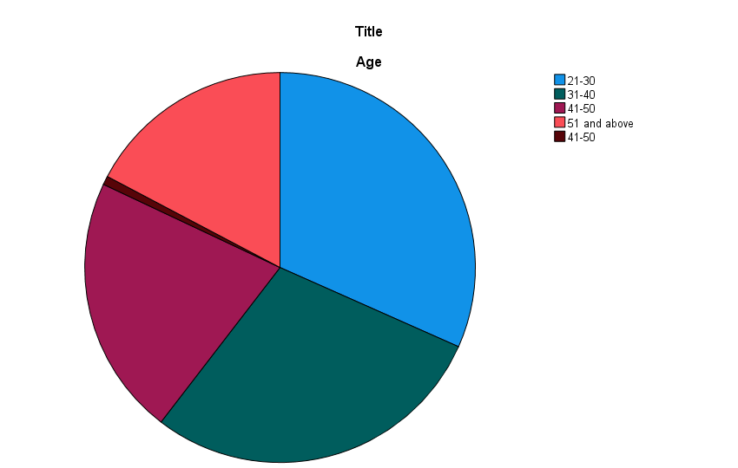

The table shows that out of 139 respondents, the majority belongs to the 21-30 age group (31.7%) followed by 31-40 (28.8%). This indicates that most participants are young and in their early or mid-career stage, where they are actively earning and making financial decisions.
Further, 21.6% of respondents are in the 41-50 age group, while 17.3% are 51 years and above. This shows that the study also includes experienced individuals with more stable financial planning. Overall, the data reflects a good mix of respondents, with a higher concentration of younger individuals.
2.Gender:
 |  | Frequency | Percent | Valid Percent | Cumulative Percent
Valid | Male | 71 | 51.1 | 51.1 | 51.1
Valid | Female | 67 | 48.2 | 48.2 | 99.3
Valid | Male | 1 | .7 | .7 | 100.0
Valid | Total | 139 | 100.0 | 100.0

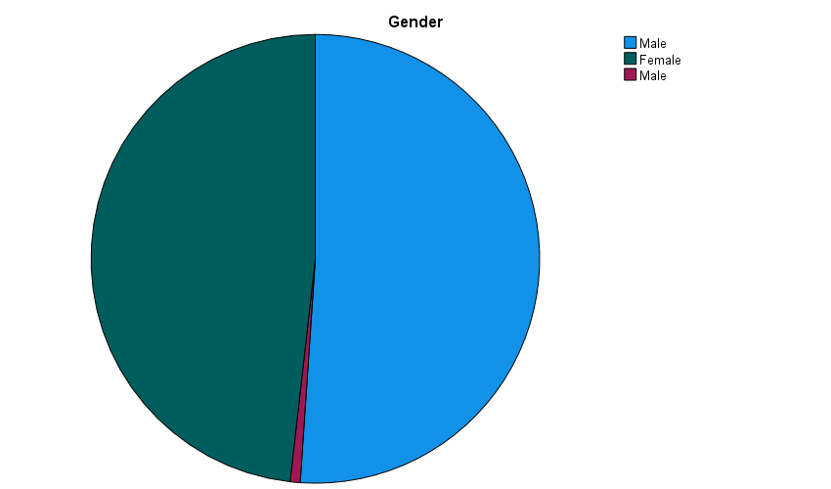
This table shows the gender distribution of respondents. Out of 139 respondents, 51.1% are male (71 respondents) and 48.2% are female (67 respondents). This indicates that the participation is almost equally distributed between male and female respondents.
There is also a very small duplicate entry (0.7%) under male, which may be due to a minor data entry error. Overall, the data reflects a balanced representation of both genders, which helps in getting a fair understanding of financial behavior across male and female respondents.

3.Marital Status
 |  | Frequency | Percent | Valid Percent | Cumulative Percent
Valid | Single | 59 | 42.4 | 42.4 | 42.4
Valid | Married | 52 | 37.4 | 37.4 | 79.9
Valid | Other | 27 | 19.4 | 19.4 | 99.3
Valid | Other | 1 | .7 | .7 | 100.0
Valid | Total | 139 | 100.0 | 100.0

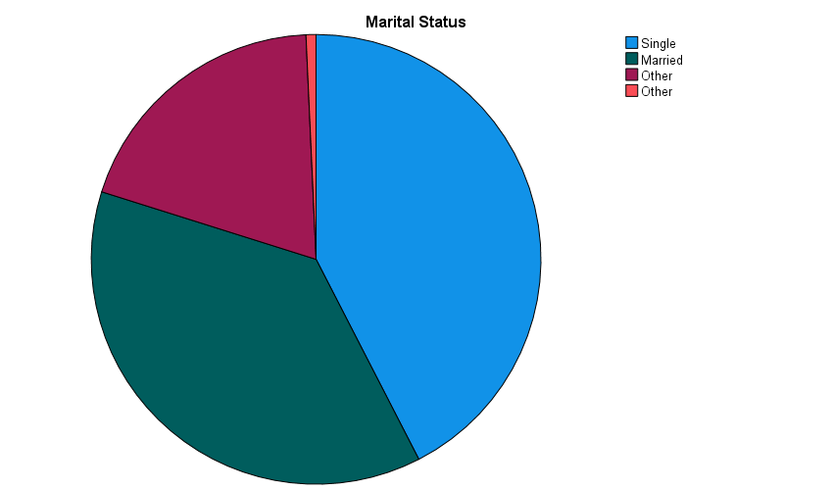

The table shows the marital status of respondents. Out of 139 respondents, 42.4% are single (59 respondents), making it the largest group. This is followed by 37.4% married respondents (52 respondents), indicating that both single and married individuals are well represented in the study.
Additionally, 19.45% of respondents fall under the “other” category, with a very small duplicate entry (0.7%) which may be due to a minor data issue. Overall, the data shows a mix of different marital statuses, allowing the study to capture varied financial behaviors across different life situations.
4.Educational Qualification
 |  | Frequency | Percent | Valid Percent | Cumulative Percent
Valid | Graduate | 52 | 37.4 | 37.4 | 37.4
Valid | Postgraduate | 39 | 28.1 | 28.1 | 65.5
Valid | Professional degree | 24 | 17.3 | 17.3 | 82.7
Valid | Undergraduate | 24 | 17.3 | 17.3 | 100.0
Valid | Total | 139 | 100.0 | 100.0
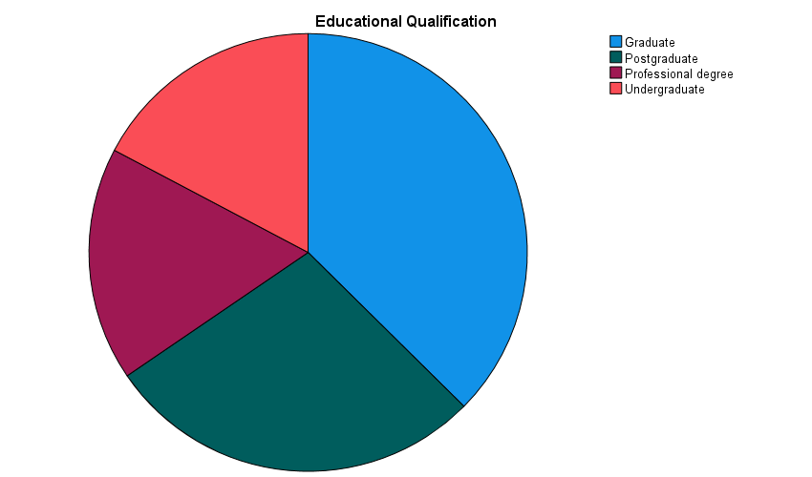
The table shows the educational qualification of respondents. Out of 139 respondents, the majority are graduates (37.4%), followed by postgraduates (28.1%). This indicates that most participants have a god level of education, which may influence their financial awareness and decision-making.
Additionally, 17.3% of respondents hold a professional degree and another 17.3% are undergraduates. Overall, the data reflects a well- educated group of respondents, which is useful for analyzing spending and investment behavior more effectively.

5.Occupation
 |  | Frequency | Percent | Valid Percent | Cumulative Percent
Valid | Government employee | 38 | 27.3 | 27.3 | 27.3
Valid | Other | 17 | 12.2 | 12.2 | 39.6
Valid | Private sector employee | 54 | 38.8 | 38.8 | 78.4
Valid | Self-employed | 30 | 21.6 | 21.6 | 100.0
Valid | Total | 139 | 100.0 | 100.0

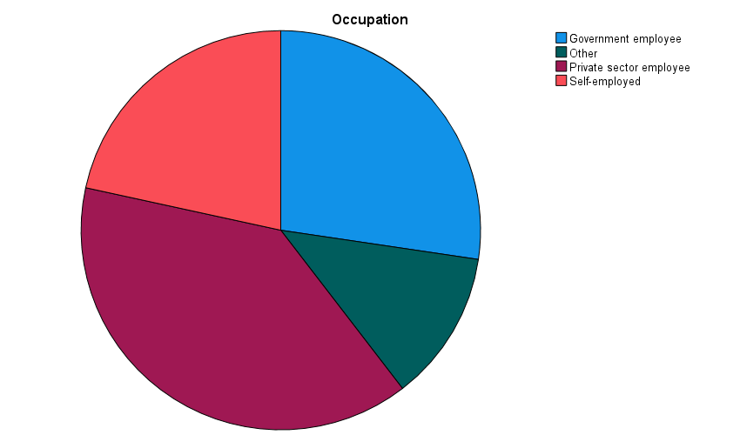
The table shows the occupation of respondents. Out of 139 respondents, the majority are private sector employee (38.8%), followed by government employees (27 .3%). This indicates that most participants are salaried individuals, which is useful for analyzing regular income and spending patterns.
Additionally, 21.6% fall under the “other” category. Overall, the data reflects a mix of different occupations, providing a broader understanding of financial behavior across various working groups.
6.Monthly Income
 |  | Frequency | Percent | Valid Percent | Cumulative Percent
Valid | Below 25000 | 24 | 17.3 | 17.4 | 17.4
Valid | 25001-50000 | 40 | 28.8 | 29.0 | 46.4
Valid | 50001-100000 | 52 | 37.4 | 37.7 | 84.1
Valid | Above 100000 | 22 | 15.8 | 15.9 | 100.0
Valid | Total | 138 | 99.3 | 100.0
Missing | System | 1 | .7
Total |  | 139 | 100.0

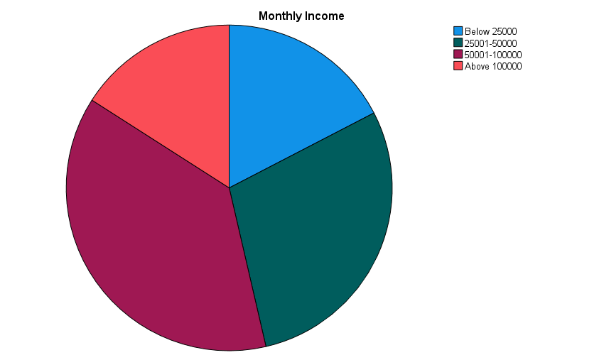
The table shows the monthly income distribution of respondents. Out of 139 respondents, the majority fall in the 50,001-1,00,000 income group (37.4%), followed by 25,001-50,000 (28.8%). This indicates that most respondents belong to the middle-income category, which is important for analyzing spending and investment behavior.
Additionally, 17.3% of respondents earn below 25,000, while 15.8% earn above 1,00,000. There is also one missing response (0.7%). Overall, the data reflects a balanced distribution across different income levels, with a higher concentration in the middle-group.
- Overall Interpretation:
The overall data shows that most of the respondents in this study are young and middle-aged people, with almost equal participation from both males and females. Most of them are well educated, mainly gradates and postgraduates, and are working in job like private sector, government sector, or self-employment. In terms of income, a large number of respondents fall in the middle-income group, which means they earn a stable income and are actively managing their daily expenses.
This group of respondents is very suitable for the study because they are directly involved in earning, spending, and making financial decisions. Their responses help in understanding how people manage their household expenses and how these expenses affect their ability to invest. Overall, the data gives a clear and practical idea or real-life financial behavior related to spending and investment.
- Analysis of Data
- Normality test analysis
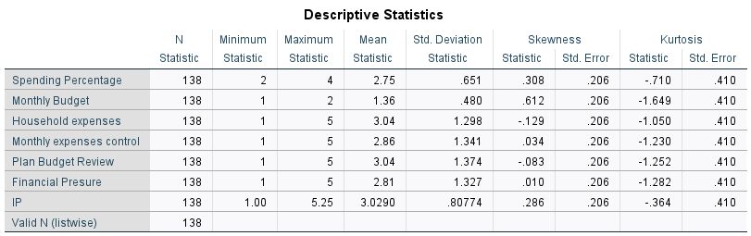

Interpretation:
A total of 138 responses were used in the analysis. The mean values of variables are mostly around the middle, which shows moderate responses. Also, all variables have skewness value close to ‘0’ and acceptable kurtosis, which means data is normally distributed and suitable for further analysis.

Variable wise interpretation
1 Spending Percentage
The mean value is 2.75, which shows that respondents spend a moderate portion of their income. The data is normally distributed, as skewness and kurtosis are acceptable limits.
2.Monthly Budget
The mean value is 1.36, indicates that many respondents follow a budget to some extent. The data is normally distributed, showing balanced responses.
3. Household Expenses
The mean value is 3.04, which shows that household expenses are at a moderate level for most respondents. The data is normally distributed.
4.Monthly expenses control
The mean value is 2.86, indicating that respondents have average control over their expenses. The data is normally distributed.
5. Plan budget review
The mean value is 3.04, which shows that respondents moderately review or plan their budget.
6. Financial pressure
The mean value is 2.81, shows that respondents feel a moderate level of financial pressure the data is normally distributed.
7. Investment Practices
The mean value is 3.029, which shows that respondents have an average level of investment behavior. The data is normally distributed for further analysis.

- Correlations
 |  | HSB | IP
HSB | Pearson Correlation | 1 | .532**
HSB | Sig. (2-tailed) |  | .000
HSB | N | 138 | 138
IP | Pearson Correlation | .532** | 1
IP | Sig. (2-tailed) | .000
IP | N | 138 | 138
**. Correlation is significant at the 0.01 level (2-tailed)

- Interpretation
The correlation analysis shows that there is a moderate positive relationship (r=0.532) between household spending behavior (HSB) and investment practices (IP). This indicates that individuals who manage their household expenses in a more planned and controlled manner are also more likely to have better investment practices. In other words, improved spending habits are associated with increased awareness and participation in investment activities.
The significance value (p=0.000) is less than 0.01, which means the relationship is statistically significant at the 1% level. Therefore, it can be concluded that household spending behavior has a significant impact on investment practices, and the result is reliable for the study. This supports the idea that effective financial management in terms of spending plays an important role in shaping investment decisions.

- Regression Analysis

Model Summary^{b}
Model | R | R Square | Adjusted R Square | Std. Error of the Estimate
1 | .532ª | .283 | .278 | .68631
a. Predictors: (Constant), HSB
b. Dependent Variable: IP

- Interpretation
The model summary shows the relationship between Household Spending Behavior (HSB) and Investment Practices (IP). The value of r= 0.532 indicates a moderate positive relationship between the two variables, meaning that better spending behavior is associated with better investment practices.
However, the r square value is 0.283, which means that only 28.3% of the variation in investment practices is explained by household spending behavior. This indicates that the model has low to moderate explanatory power, and a large portion (71.7%) of the variation in investment practices is influenced by other factors not included in the model.
The Adjusted r square (0.278) is very close to r square, which suggest that the model is stable and not overfitted. The standard error (0.68631) shows some level if variation in the prediction, indicating that the model does not perfectly predict investment behavior.
Overall, result suggest that although household spending behavior has a statistically significant impact on investment practices, its influence is not very strong and investment decisions are affected by multiple other factors such as income, financial awareness, and individual preferences.

ANOVAª
Model |  | Sum of Squares | df | Mean Square | F | Sig.
1 | Regression | 25.326 | 1 | 25.326 | 53.768 | .000^{b}
1 | Residual | 64.058 | 136 | .471
1 | Total | 89.384 | 137
a. Dependent Variable: IP
b. Predictors: (Constant), HSB

The ANOVA table shows whether the regression mode is statistically significant or not. In this study, the F value is 53.768 and significance value (p= 0.000) is less than 0.05, which means the model is statistically significant. This indicates that household spending behavior (HSB) has a significant effect on investment practices (IP) and the results are not due to chance. In simple words, the overall regression model is a good fit and can be used to explain the relationship between spending behavior and investment.

Coefficientsª
Model |  | Unstandardized Coefficients |  | Standardized Coefficients | t | Sig.
 |  | B | Std. Error | Beta | t | Sig.
1 | (Constant) | 1.808 | .177 |  | 10.240 | .000
1 | HSB | .462 | .063 | .532 | 7.333 | .000
a. Dependent Variable: IP

Variables Entered/Removedª
Model | Variables Entered | Variables Removed | Method
1 | HSB^{b} | . | Enter
a. Dependent Variable: IP
b. All requested variables entered.

The table show that Household Spending Behavior
(HSB) is used to predict investment practices (IP) using the Enter method. The result indicate a positive and significant impact, as the beta value is 0.462 and significance value is 0.000. this means that better spending behavior leads to better investment practices.
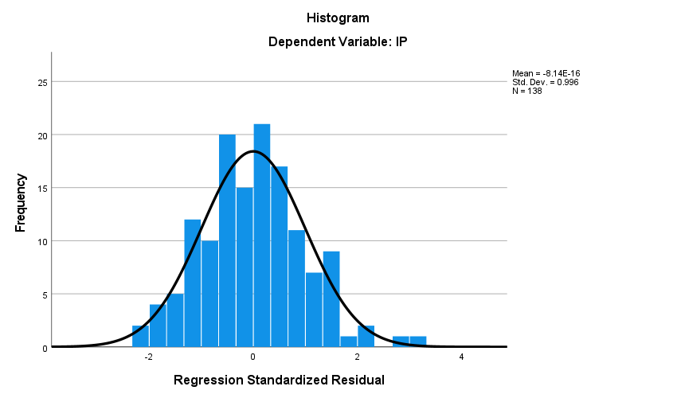

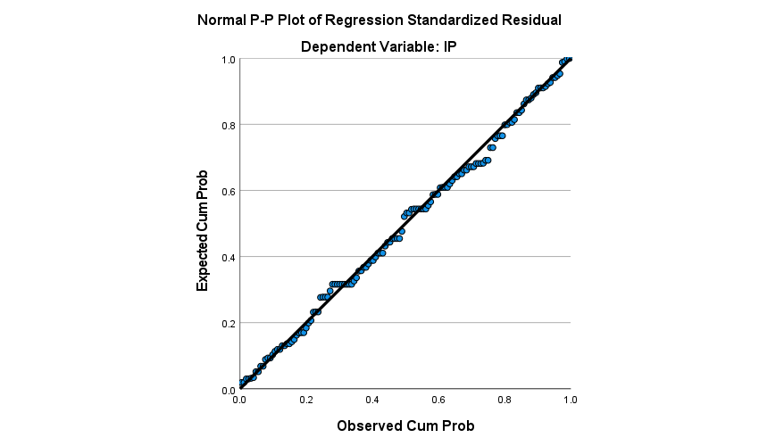

Chapter V
FINDINGS
Demographic Observation

